**Answer1**: Selenium is a popular suite of tools for automating web browsers. It's primarily used for testing web applications but can also be used for other browser automation tasks. The Selenium suite consists of several components, each serving a different purpose. Here's a breakdown of the differences between Selenium IDE, Selenium WebDriver, and Selenium Grid:

1. **Selenium IDE (Integrated Development Environment)**: It is a browser extension for Firefox and Chrome, allowing for record-and-playback of interactions with the browser. **Use Case**: Primarily used for simple test case recording and playback. It's useful for creating quick test cases, especially for users who are not familiar with programming. **Limitations**: Less flexible and powerful compared to WebDriver. It's not suitable for complex test scenarios and lacks the capability for programming logic, conditional operations, looping, etc.

**Target Users**: Best for beginners or non-programmers who need to automate simple tasks in a browser.

1. **Selenium WebDriver**: A collection of language-specific APIs to control a browser.

**Use Case**: Used to create more complex and robust test cases. It supports various programming languages like Java, C#, Python, Ruby, etc., allowing for writing more sophisticated test scripts.

**Capabilities**: WebDriver can interact with web pages, handle different browser types, work with different OS, and perform complex actions like drag-and-drop, handling pop-ups, etc.

**Target Users**: Suitable for developers and testers who are comfortable with programming. It's the core of Selenium for serious test automation.

1. **Selenium Grid**: A server that allows tests to use web browser instances running on remote machines.

**Use Case**: Used to run tests in parallel across different machines and different browsers simultaneously. This significantly reduces the time for test execution and helps in testing under various environments.

**Capabilities**: It allows for scaling the testing by distributing tests across several physical or virtual machines.

**Target Users**: Ideal for teams that need to run a large number of tests or tests that must be run in different environments. Useful in Continuous Integration (CI) pipelines.

In summary:

**Selenium IDE** is a simple, record-and-playback tool for quick test creation.

**Selenium WebDriver** is a more powerful tool for creating complex and programmable test scripts.

**Selenium Grid** is used for running tests in parallel across different environments, speeding up test execution and facilitating cross-environment testing.

**Answer2**: Below is the Selenium script to open google and search for “Selenium Browser Driver”.

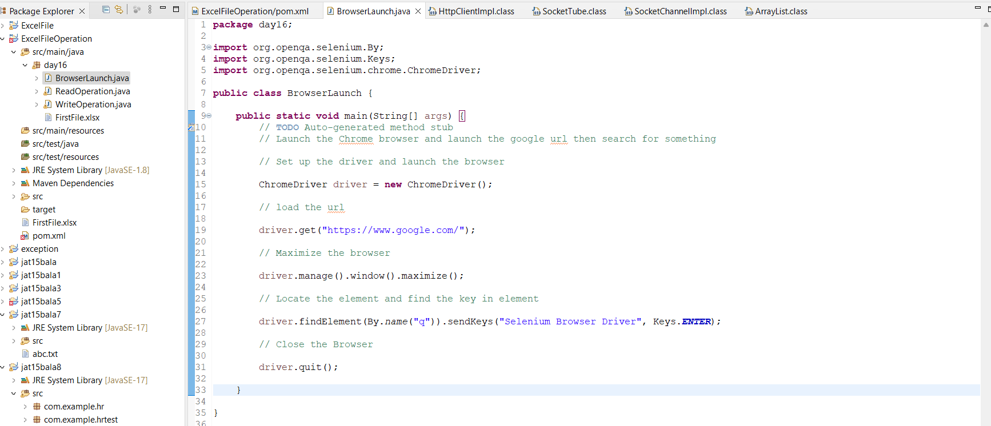

Output Screenshot:

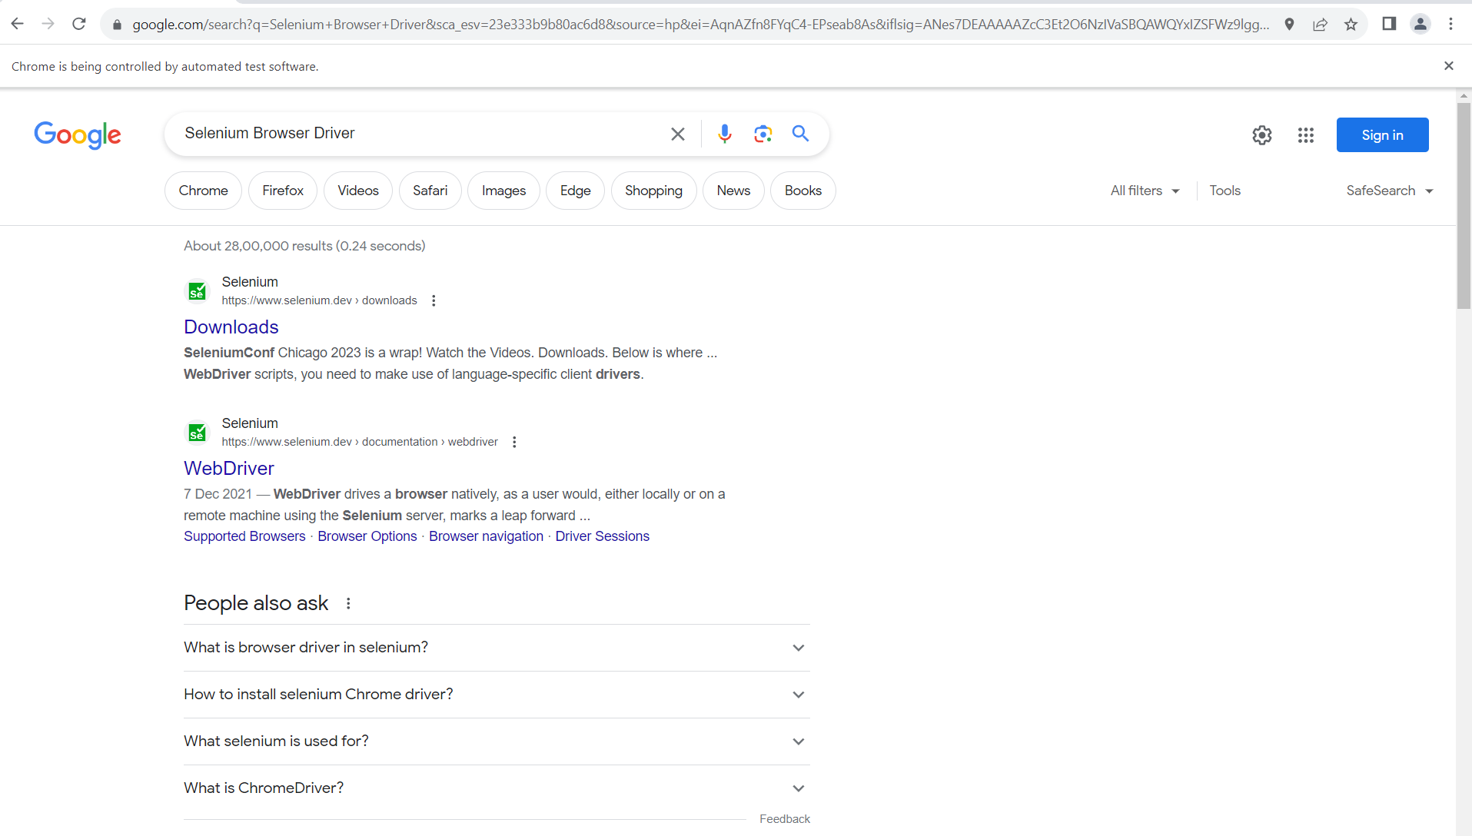

**Answer3**: Selenium is an open-source automated testing framework used to validate web applications across different browsers and platforms. It's one of the most popular tools for web application testing, though it can also be used for automating web-based administration tasks. Here are some key aspects of Selenium and its usefulness in automation testing:

1. **Browser Compatibility Testing**: Selenium supports multiple browsers like Chrome, Firefox, Safari, and Internet Explorer. This allows testers to ensure that web applications function correctly across various browsers.
2. **Supports Various Programming Languages**: Selenium supports a variety of programming languages including Java, C#, Python, Ruby, Perl, and JavaScript. This makes it a flexible choice for teams with varying programming skills.
3. **Cross-Platform Testing**: Selenium can run on different operating systems like Windows, Mac, and Linux, enabling cross-platform testing of web applications.
4. **Selenium WebDriver**: It's the core component of the Selenium suite, allowing for the creation of more complex and robust browser-based regression automation suites and tests. WebDriver directly interacts with the browser and uses its native compatibility to automate.
5. **Selenium Grid**: Used in conjunction with WebDriver, it enables execution of tests in parallel, on different browsers and environments. This is crucial for reducing test execution time and ensuring the application works in various environments.
6. **Integration with Other Tools**: Selenium can be integrated with tools like TestNG and JUnit for managing test cases and generating reports. It can also integrate with Maven or Jenkins for continuous testing.
7. **Community and Support**: Being an open-source tool, it has a large and active community for support, which is beneficial for resolving issues and learning new features.
8. **Cost-Effective**: As an open-source tool, it’s free to use, which reduces software testing costs.
9. **Flexibility and Scalability**: Selenium's flexibility allows testers to write advanced test scripts to handle complex scenarios. It's also scalable for large test suites.
10. **Record and Playback**: Through tools like Selenium IDE, users can record their actions in the browser and replay them as tests, which is helpful for beginners or for creating tests quickly.

In summary, Selenium is highly useful in automation testing because of its compatibility with multiple browsers and platforms, support for various programming languages, ability to integrate with other testing tools, and its cost-effectiveness. These features make it a go-to choice for automation testing in many organizations.

**Answer4**: In Selenium, browser drivers are essential components that enable interaction between your test code and the web browser. Each major browser has its own driver, which acts as a link between the Selenium commands and the browser's native commands. Here's a list of the common browser drivers used in Selenium:

1. **ChromeDriver**: Used for automating Google Chrome. It is maintained by the Chromium project.
2. **GeckoDriver**: This driver is used for Mozilla Firefox. It is an implementation of the WebDriver protocol developed by Mozilla.
3. **EdgeDriver**: Specifically designed for Microsoft Edge browser. There are different versions of EdgeDriver for the legacy Edge based on EdgeHTML and the new Edge based on Chromium.
4. **InternetExplorerDriver**: Used for automating tests on the Internet Explorer browser. It's important to note that since Internet Explorer has been largely replaced by Microsoft Edge, this driver is less frequently used.
5. **OperaDriver**: While less common, this driver is used for Opera browser. Given that Opera is based on Chromium, OperaDriver is actually an extension of ChromeDriver.
6. **SafariDriver**: Used for Apple's Safari browser. With the release of Safari 10, the SafariDriver is included with the browser itself.

Each of these drivers enables Selenium to communicate with their respective browser in a way that mimics user interactions. When writing tests in Selenium, you need to initialize the specific driver for the browser you intend to test. This often involves downloading the executable driver file for the browser and setting the path to this driver in your test code or system environment.

It's also important to keep the browser drivers updated to ensure compatibility with the latest versions of browsers and to take advantage of improvements and bug fixes in the drivers themselves.

**Answer5**: To create a simple WebDriver script in Java, we would follow these steps:

1. Make sure Java is installed in the system.

Download the WebDriver executable for the browser (e.g ChromeDriver for Google Chrome).

Include the Selenium WebDriver Java bindings in the project. We can download the jar files or use a build automation tool like Maven.

using Maven, we will add the following dependency to pom.xml:

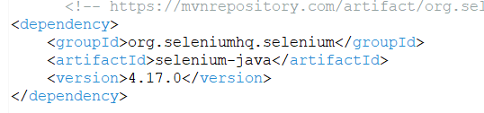

1. Create a class named “BrowserLaunch” in the package “day16”.

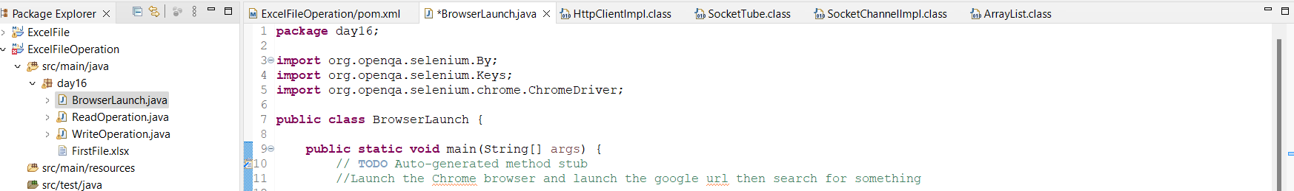

1. Set up the ChromeDriver and launch the Chrome Browser.

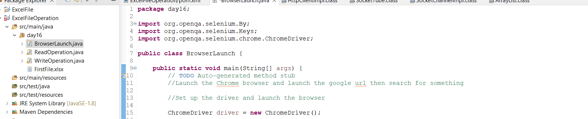

1. Load the url “https://www.google.com/".

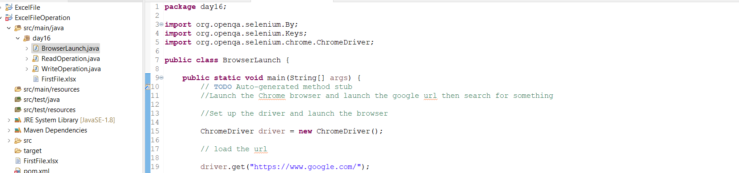

1. Maximize the browser.

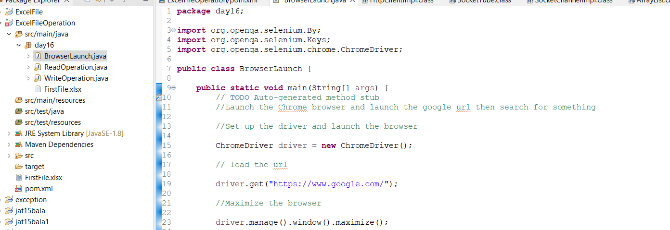

1. Locate the element using the name and find the key (“Selenium Browser Driver”) in the element and “ENTER” key as well.

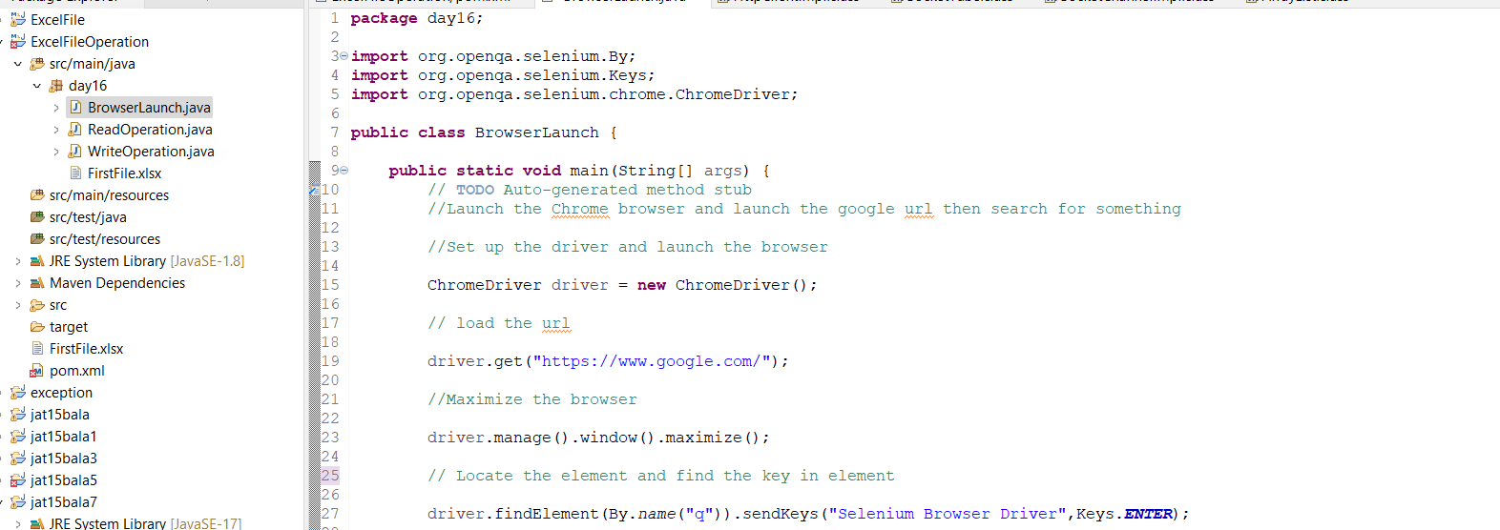

1. Close the browser.



These are the steps to create a simple webdriver script.